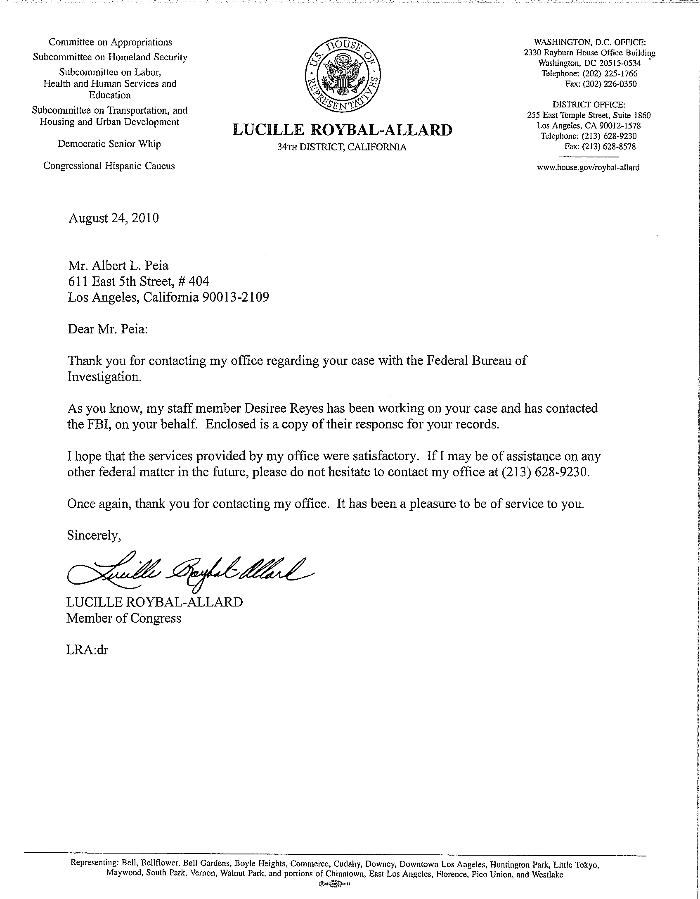
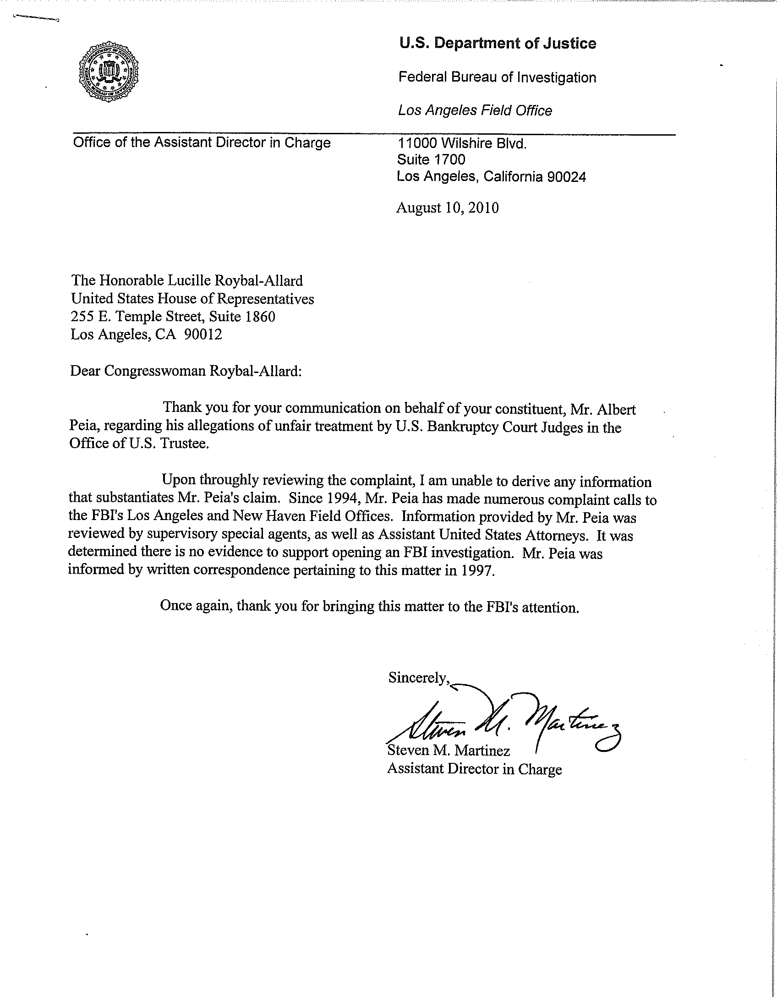
From:
"albert peia" <albert_peia@yahoo.com>

To:
"DesireeReyes" <Desiree.Reyes@mail.house.gov>
Thank you Ms. Reyes:
Mr. Martinez was not in but I'm to call back on Monday, 9-13-10. I reminded them that Congresswoman Roybal-Allard's district is not without financial interest (liens) in the proper resolution of this in accordance with law and the inaccuracy of their correspondence inasmuch as there is a plethora of evidence to support not just an investigation but criminal charges as well. This was a typical 'cya' letter from them that perpetuates the cover-up, the complicit corruption in the process, and is without foundation in fact; and hence, I will pursue a more definitive position from them at the very least.
Regards and good luck,
Al Peia
--- On Fri, 9/10/10, Reyes, Desiree <Desiree.Reyes@mail.house.gov> wrote:
From: Reyes, Desiree <Desiree.Reyes@mail.house.gov>
Subject:
To: "'albert_peia@yahoo.com'" <albert_peia@yahoo.com>
Date: Friday, September 10, 2010, 2:51 PM
Good afternoon Mr. Peia:

I am sorry that you never received this correspondence in the mail. Attached is a letter from the Congresswoman as well as the communication from the FBI regarding your request for assistance. Please let me know if you have any trouble viewing the attached documents. I apologize that we could not be or more help in this matter.

Respectfully,

Desiree Reyes|Staff Assistant/Caseworker

Office of Congresswoman Lucille Roybal-Allard
Edward Roybal Federal Building
255 East Temple Street | Suite 1860 | Los Angeles, Ca 90012
Tel. 213. 628.9230

U.S. Representative Lucille Roybal-Allard CA-34
The multicultural 34th Congressional District includes: Bell, Bellflower, Bell Gardens, Boyle Heights, Commerce, Cudahy, Downey, Downtown Los Angeles, Huntington Park, Little Tokyo, Maywood, South Park, Vernon, Walnut Park and portions of Chinatown, East Los Angeles, Florence, Pico Union and Westlake.

